**React 10**

**Aim**: Estimated time to complete this lab: 60 minutes.

Create a React Application named “officespacerentalapp” which uses React JSX to create elements, attributes and renders DOM to display the page.

Create an element to display the heading of the page.

Attribute to display the image of the office space

Create an object of office to display the details like Name, Rent and Address.

Create a list of Object and loop through the office space item to display more data.

To apply Css, Display the color of the Rent in Red if it’s below 60000 and in Green if it’s above 60000.

**Index.js:**

import React from 'react';

import ReactDOM from 'react-dom/client';

import './index.css';

import App from './App';

const root = ReactDOM.createRoot(document.getElementById('root'));

root.render(<App />);

**Index.css:**

body {

  margin: 0;

  font-family: -apple-system, BlinkMacSystemFont, 'Segoe UI', 'Roboto', 'Oxygen',

    'Ubuntu', 'Cantarell', 'Fira Sans', 'Droid Sans', 'Helvetica Neue',

    sans-serif;

  -webkit-font-smoothing: antialiased;

  -moz-osx-font-smoothing: grayscale;

}

code {

  font-family: source-code-pro, Menlo, Monaco, Consolas, 'Courier New',

    monospace;

}

* {

  box-sizing: border-box;

}

**App.css:**

body {

  margin: 0;

  font-family: 'Segoe UI', sans-serif;

  background-color: #eef6f9;

  color: #222;

}

.app-container {

  padding: 1.5rem;

}

header {

  text-align: center;

  margin-bottom: 2rem;

}

header h1 {

  font-size: 2.5rem;

  color: #0077b6;

}

.subheading {

  font-size: 1.1rem;

  color: #0096c7;

}

.search-box {

  margin-top: 1rem;

  padding: 0.7rem;

  width: 90%;

  max-width: 400px;

  border: 1px solid #ccc;

  border-radius: 8px;

  font-size: 1rem;

}

.card {

  background-color: white;

  border-radius: 12px;

  box-shadow: 0 4px 10px rgba(0, 0, 0, 0.1);

  margin: 1rem auto;

  padding: 1rem;

  max-width: 600px;

}

.card img {

  width: 100%;

  height: auto;

  border-radius: 10px;

}

.card .info {

  text-align: left;

  margin-top: 1rem;

}

.low-rent {

  color: crimson;

  font-weight: bold;

}

.high-rent {

  color: forestgreen;

  font-weight: bold;

}

/* Responsive */

@media (max-width: 600px) {

  .search-box {

    width: 100%;

  }

  .card {

    padding: 0.5rem;

  }

}

**App.js:**

import React, { useState } from "react";

import "./App.css";

const officeList = [

  {

    name: "Cyber Heights",

    rent: 55000,

    address: "123 Tech Park, Hyderabad",

    image: "https://via.placeholder.com/400x200?text=Cyber+Heights"

  },

  {

    name: "Tech Tower",

    rent: 72000,

    address: "456 IT Road, Bengaluru",

    image: "https://via.placeholder.com/400x200?text=Tech+Tower"

  },

  {

    name: "Startup Hub",

    rent: 48000,

    address: "789 Innovation Ave, Pune",

    image: "https://via.placeholder.com/400x200?text=Startup+Hub"

  }

];

function App() {

  const [searchTerm, setSearchTerm] = useState("");

  const filteredOffices = officeList.filter((office) =>

    office.name.toLowerCase().includes(searchTerm.toLowerCase())

  );

  return (

    <main className="app-container">

      <header>

        <h1>🏢 Office Space Rental App</h1>

        <p className="subheading">Find your perfect workspace today!</p>

        <input

          type="text"

          placeholder="🔍 Search office by name..."

          className="search-box"

          value={searchTerm}

          onChange={(e) => setSearchTerm(e.target.value)}

          aria-label="Search Office"

        />

      </header>

      <section>

        {filteredOffices.length === 0 ? (

          <p>No offices found for your search.</p>

        ) : (

          filteredOffices.map((office, index) => (

            <article className="card" key={index}>

              <img src={office.image} alt={`Office: ${office.name}`} />

              <div className="info">

                <h2>{office.name}</h2>

                <p><strong>📍 Address:</strong> {office.address}</p>

                <p>

                  <strong>💰 Rent:</strong>{" "}

                  <span className={office.rent < 60000 ? "low-rent" : "high-rent"}>

                    ₹{office.rent}

                  </span>

                </p>

              </div>

            </article>

          ))

        )}

      </section>

    </main>

  );

}

export default App;

**Output 01:**

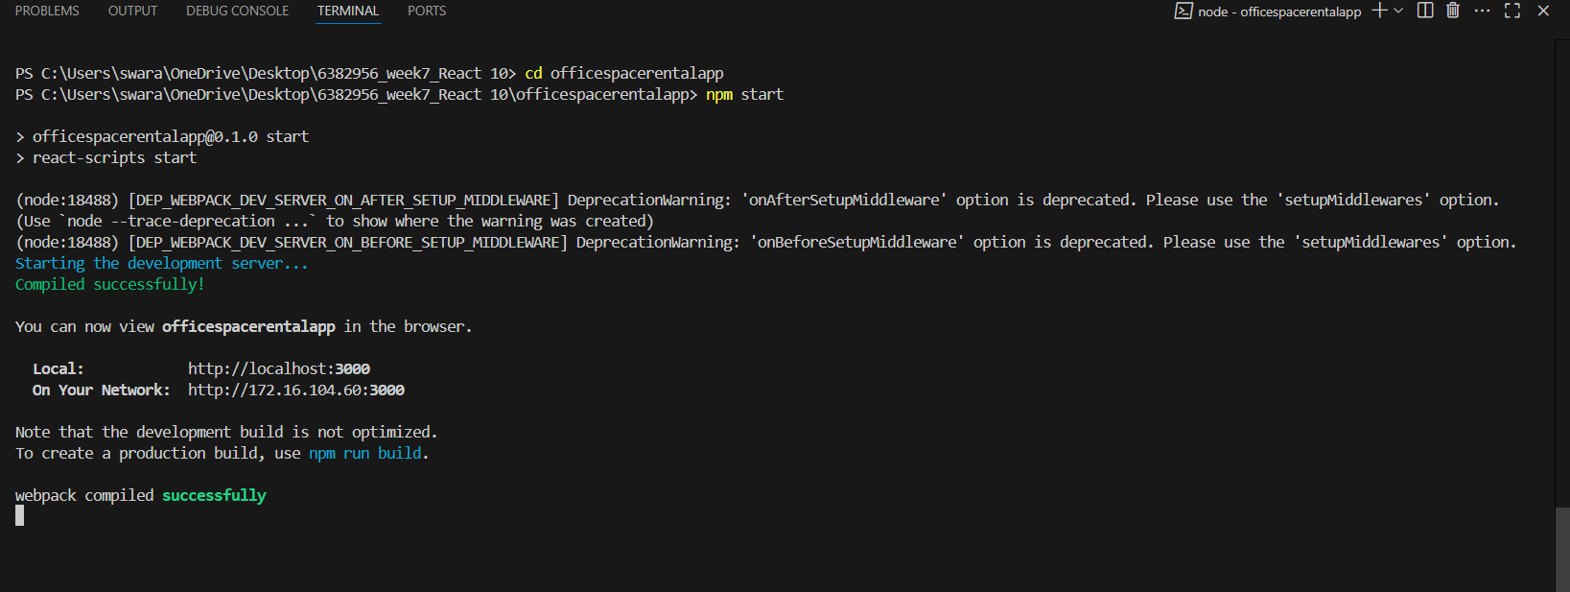

**Output 02:**

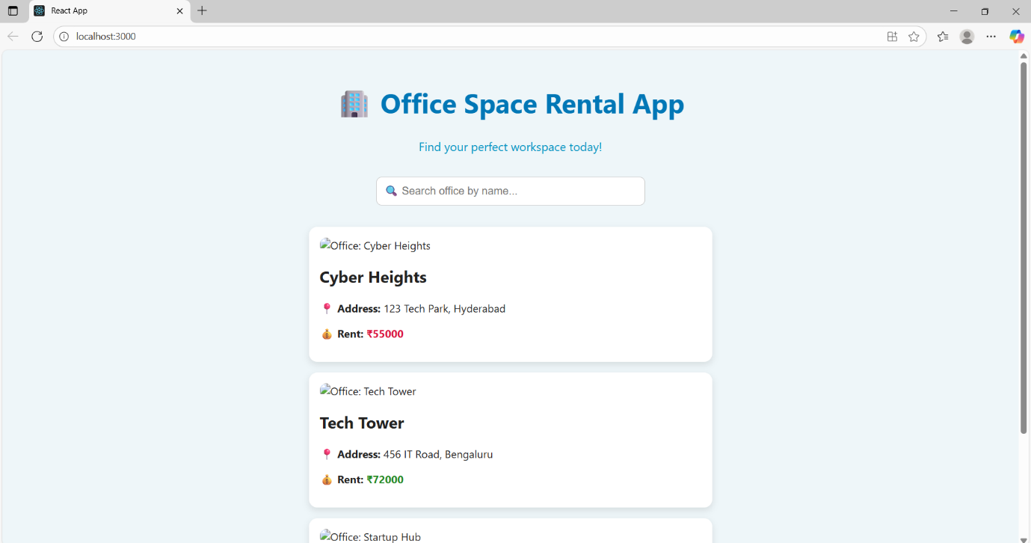

**Output 03:**

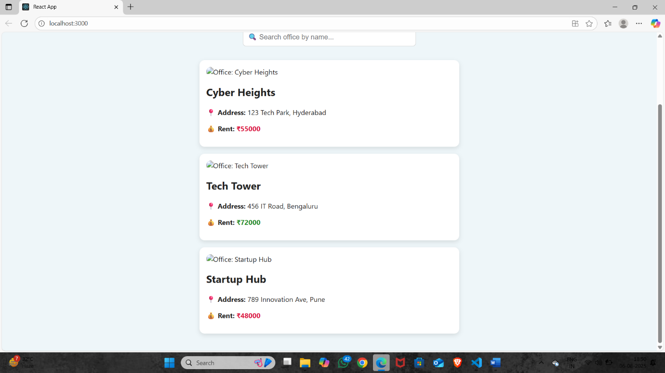

**Output 04:**

